FRIENDS OF BISHOP’S HOUSE, IONA

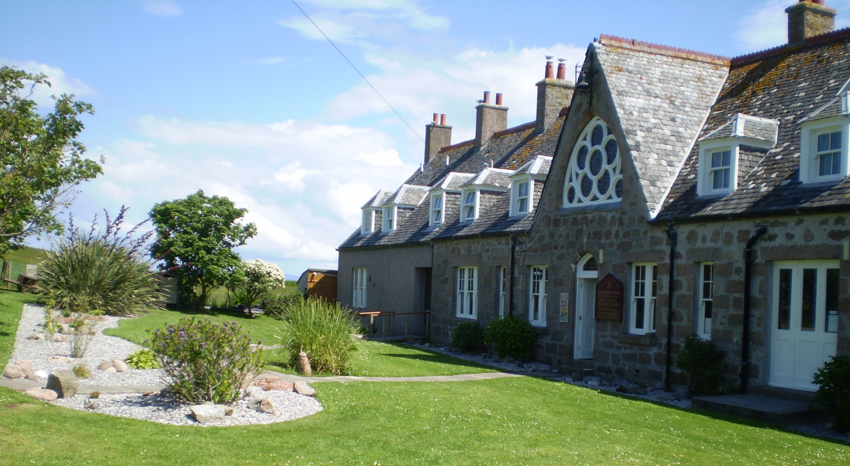
Bishop’s House
IONA
Argyll
PA76 6SJ
01681 700111

NEWSLETTER – SPRING 2012

In contrast to last year’s Spring newsletter, this year it is with sadness I tell you Ben, Justine and Theresa have left Bishop’s House (please see Ben’s attached / enclosed letter). Ben and his family have moved to Birmingham to spend some time with his parents before they start their new life in the USA. During ‘work week’ Ben was given a card and gift, as a token of the Friend’s appreciation for his hard work and visionary contribution to the continued development of Bishop’s House as a place of retreat, sacrament and learning. Robbie and Elizabeth will ‘hold the fort’ until another warden is appointed, and Joyce Watson will provide her continued valuable ministerial support to staff, volunteers and guests.

You will see in Ben’s letter a summary of the improvements made to the house over these winter months, and the news that there is now planning permission for the new extension to the house, work beginning over the next winter, to be completed before the 2013 season.

Ben also writes:
In 2009 Duncraig Retreat house closed due to the requirement for renovation that was beyond their budget. After the house had sold and the trustees had discharged their affairs, the remainder of the capital was donated to Bishops House. Over season 2010 /11 we have conducted a survey of our guests which has revealed that the two largest problems are a lack of single rooms and the smallness of South lounge.
We will be using the Duncraig money to enable a new extension to the South end of Bishops House. The extension (see plan below) will more than double the size of the South lounge and increase our number of single bed rooms. We will extend the ground floor corridor through the current shower room to enable access directly to the South lounge, thus enabling the Library to become a quiet lounge. In the upper floor we will create two new twin rooms and a bath room, enabling us to make four of the small existing rooms into single rooms.
At the end of the extension Bishops House will still take twenty-three guests but in seven single and eight twin rooms, a far better balance for both group and individual retreats. The Library will cease to function as a corridor and the lounge will have more space for both groups and individuals to enjoy.
Returning recently from ‘work week’ at Bishop’s House it was a great pleasure to meet more Friends, some have been to Iona for many years before the season starts, helping staff prepare the house with extra polishing, digging and weeding. During the hard work, we had much fun and happy memories to take away, some of which should be shared with you all. For one, Peter, John and Brian installed land drainage in the boggy area of the rear garden. Digging the trench revealed continuous spring or ground water. They had an idea to bottle the water as a fund-raising project, calling it either ‘Bishop’s Water’ or perhaps ‘Ionic Brew’. After the old ‘giffes’ stopped dreaming, they reinstated the boundary wall!
Liz Toy remembers, when working as Cook in 1974 /75 pumping all the water for cooking and for drinking at meals up from a well using a handle to the left of the sink in front of the kitchen window - that could be the spring that was found. They also pumped water to be placed on the landing as drinking water upstairs.!
And then there was the sight of one Friend, (who shall remain nameless, unless the Sec is bribed well!) in the frenzy of cleaning the chapel, asking a hand-brush ‘why aren’t you a polishing cloth’!!

The email list for Bishop’s House is still active, offering last minute deals for groups and individuals at discounted rates. Contact Elizabeth or the new warden direct by e-mail at bhiona@argyll.anglican.org if you would like your name to be added to the list.

I enclose an Agenda for the AGM, if you are unable to attend on 21 June, let me have comments or anything adding to the Wish List or anything you wish to have raised under AOB, by 4 June. For those attending the AGM, remember to bring your copy of the Minutes, sent in the Autumn 2011 Newsletter.

Subscriptions for 2012 are now due to be paid by those who do not have a Standing Order, an individual subscription is £15.00 and for a couple £25.00. Cheques, payable to “Friends of Bishop’s House, Iona” should be sent to Revd. Clephane Hume, Honorary Treasurer, 30 Findhorn Place, EDINBURGH, EH9 2JP (Tel: 0131 667 2996). Thank you, Clephane, on behalf of all Friends, for the hard work you have put in this year as Honorary Treasurer. Clephane has asked that while subscriptions are due in September, any payments earlier than that would be most welcome!

I am still awaiting a volunteer to take on the task of collating and supplying information about the Friends for a page on the Islands Retreat web site. You would not be expected to actually set up the page, only supply regular updates of information. Please get in touch with me if you think this might be a task with which you could cope.

In the last newsletter it was suggested we might produce a Bishop’s House Recipe book; sadly the response in supplying favourite recipes was quite poor. However, Yvonne has collated the few sent and these will be available to buy on Iona this year. Also, if anyone has an unwanted set of golf clubs they could donate to the House, please contact me,we’ll find a way to transport them to Iona.

Friends will again hold a major fund-raising for Bishop’s House on the Island, a Coffee Morning and Sale, on Thursday, 21 June. If you would like to make a donation, or have gifts of jewellery, bric-a-brac, books or handicrafts, please either bring them to Friends’ Week or send them to Dorothy Jamal or myself at Bishop’s House but not before Saturday, 16 June.

Again, if you receive this newsletter by post and now have an e-mail address, please let me have the details, or indeed if there are changes to your postal address.
The Revd Pat Baggaley, Anglesea, Rosebery Road, West Runton,
CROMER NR27 9QW. 01263 837490 baggaley157@btinternet.com

